**EXPERIMENT NO – 5**

**TITLE: Master/Slave concept in Jenkins**

**Objective: -**

Create at least Two slaves in Jenkins and Run two different jobs in two slaves parallel.

1. Create 2 slaves on your local drive



1. Go to manage Jenkins and make 2 nodes-slave1, slave2

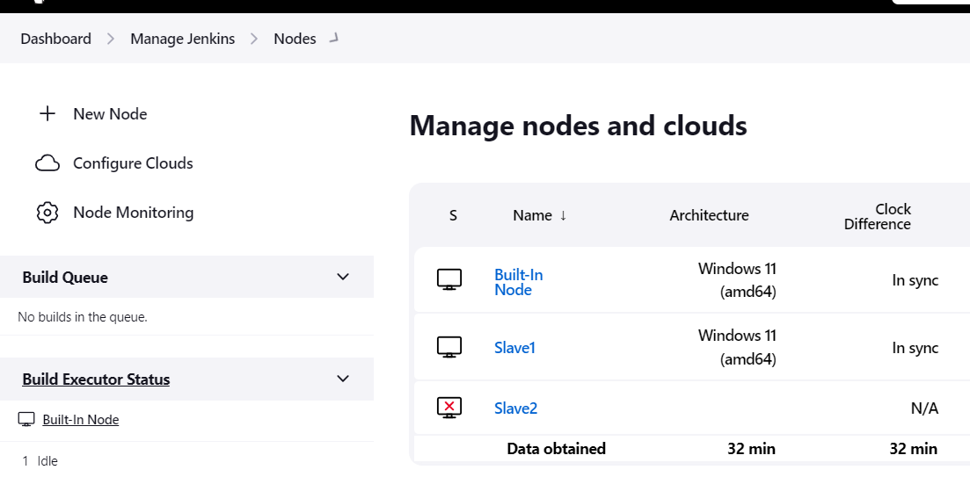

* Set as permanent agent
* Label it as Agent1
* Set remote root repo path of your local system :

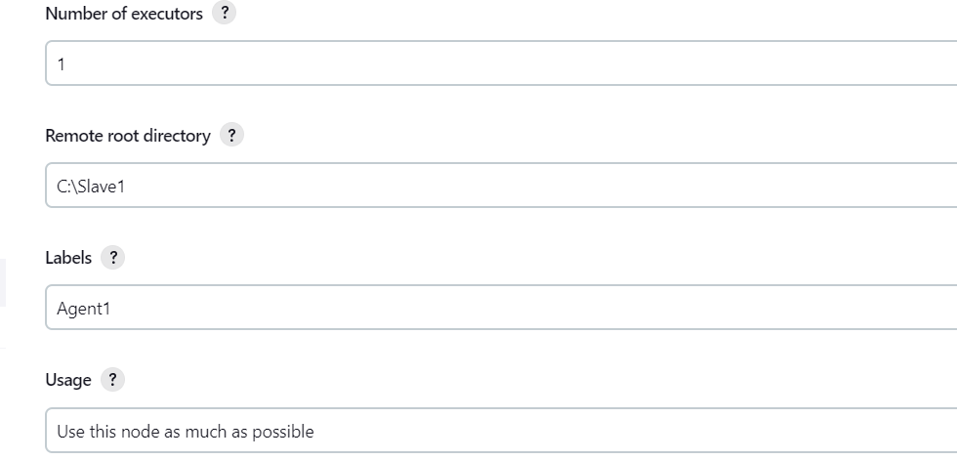

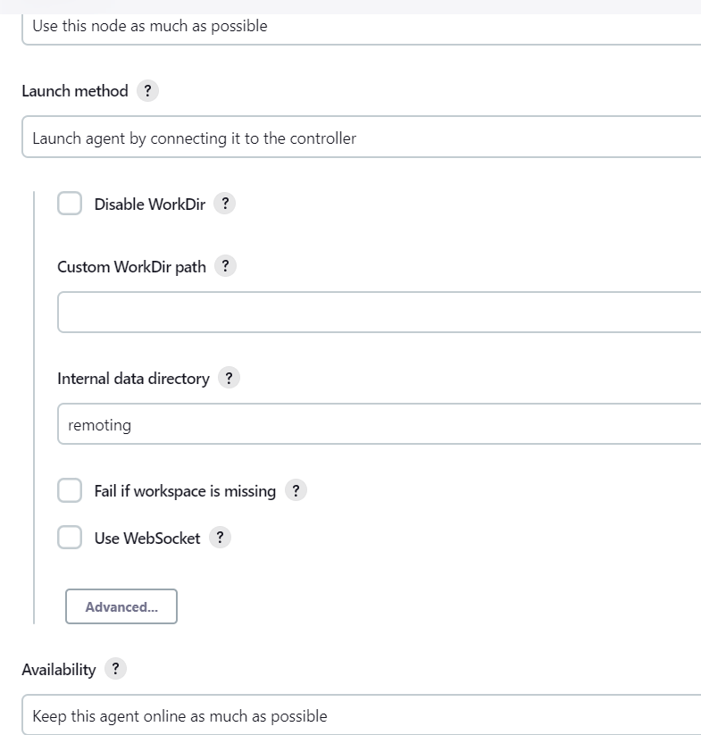

* Then save it

1. Go to your cmd of slave1 and run these commands

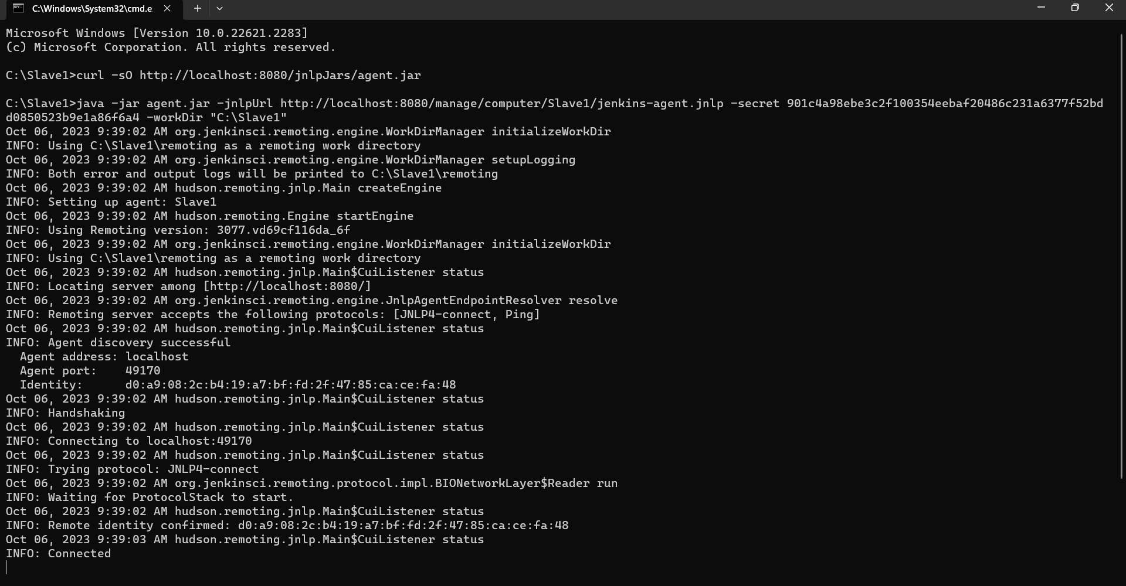

* Slave2

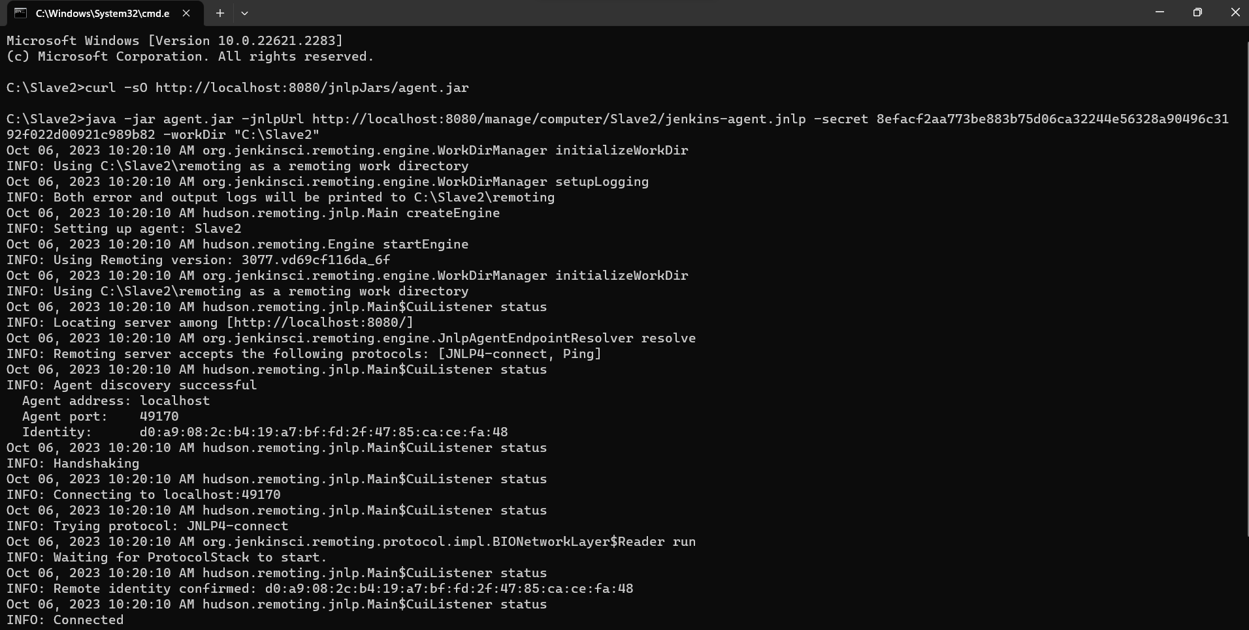

* This slave is connected and now using this slave we’ll make a build-

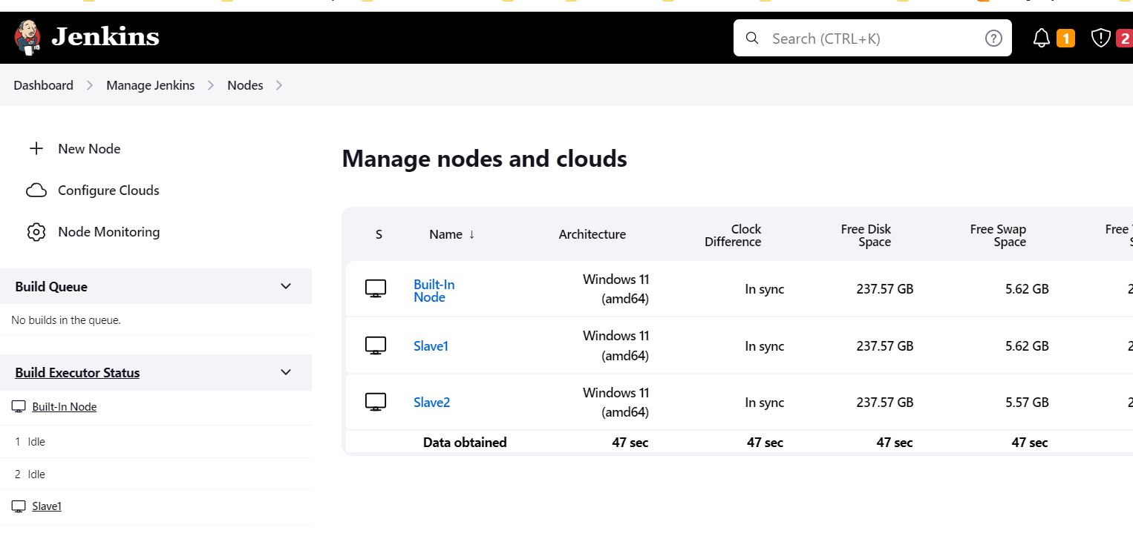

1. Make a new maven project and connect it to github project for makin automatic build(cicd-lab-5)

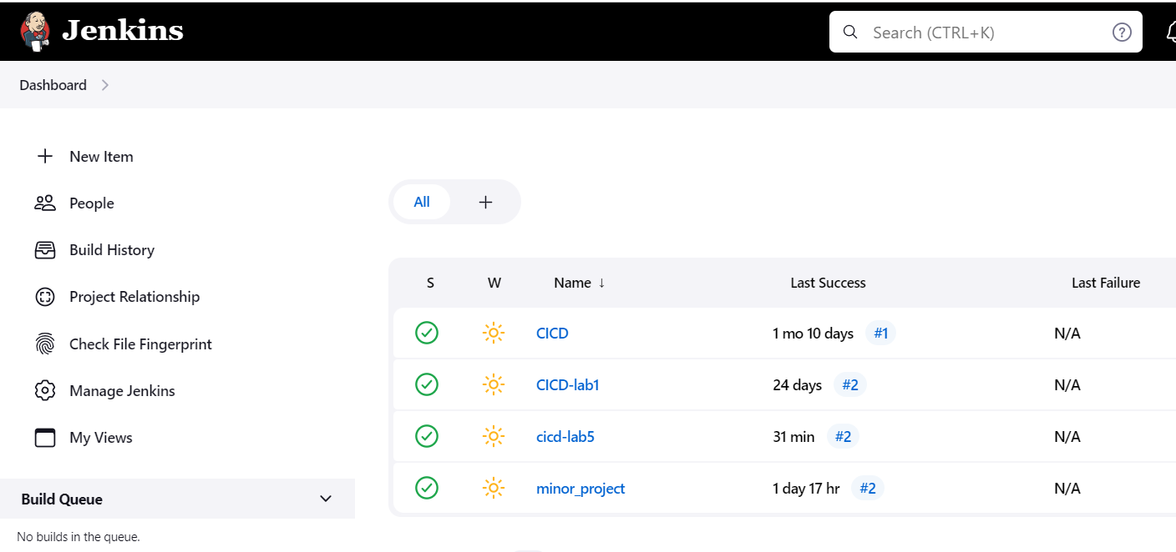

* Connect it with agent1

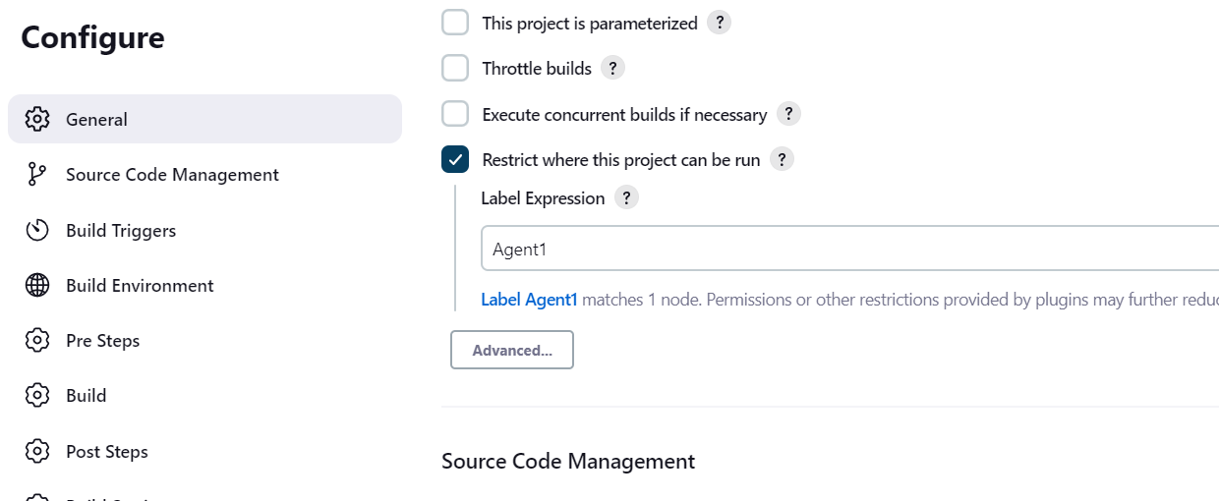

* Give you repo URL

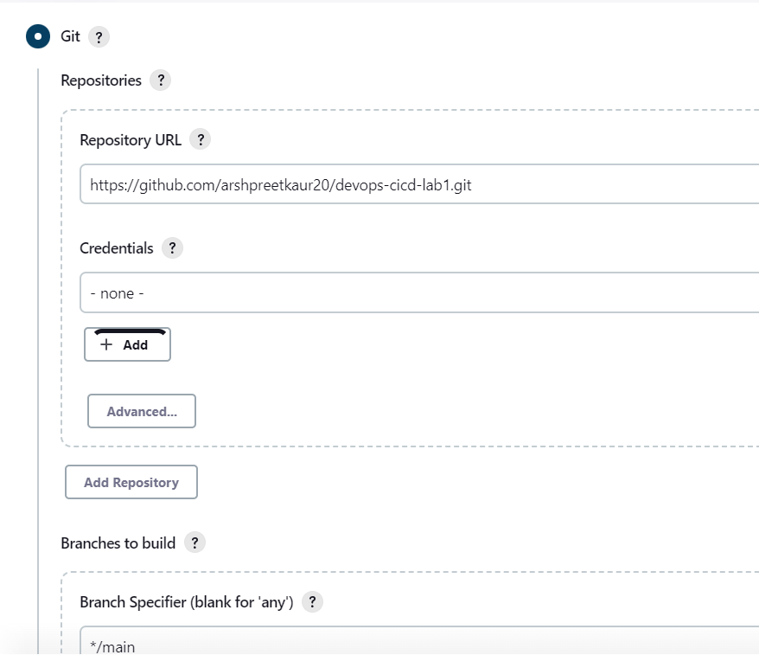

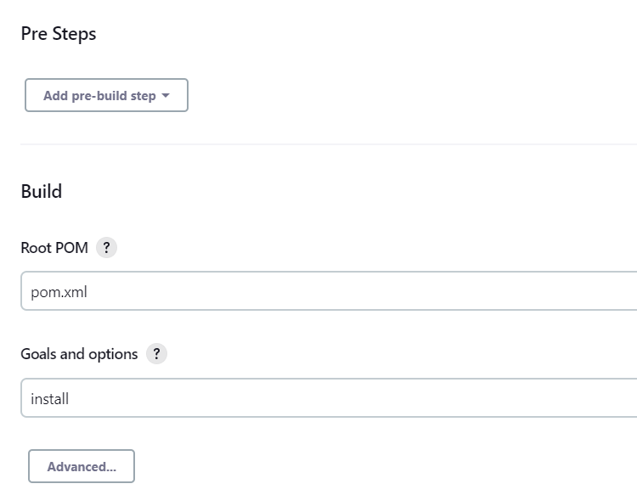

* Build it

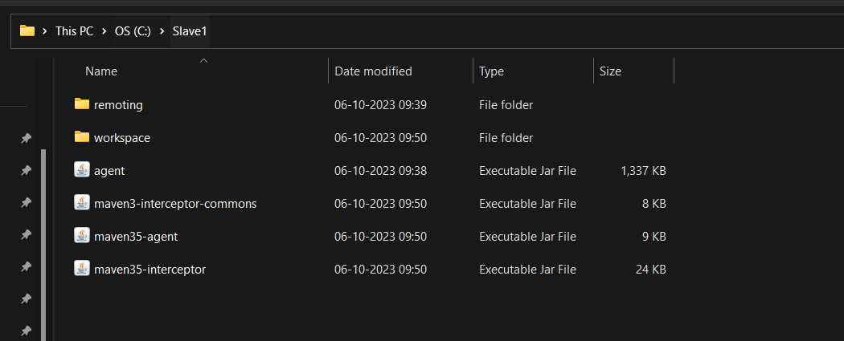

1. Now make another maven project on jenkins with label Agent2 . and give your path of local system to run different agents of same project to run processes parallely

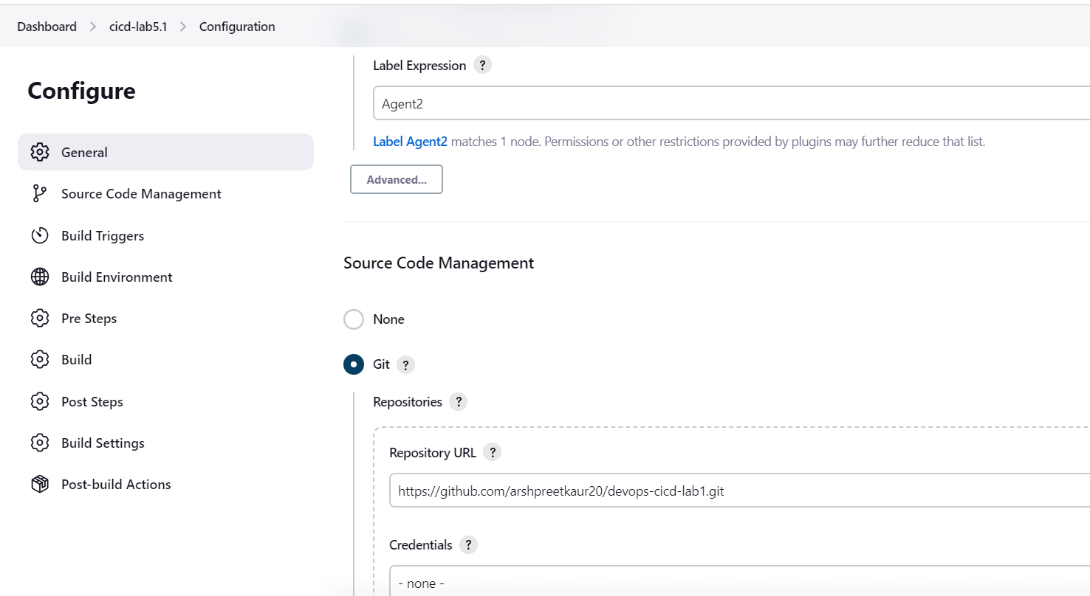

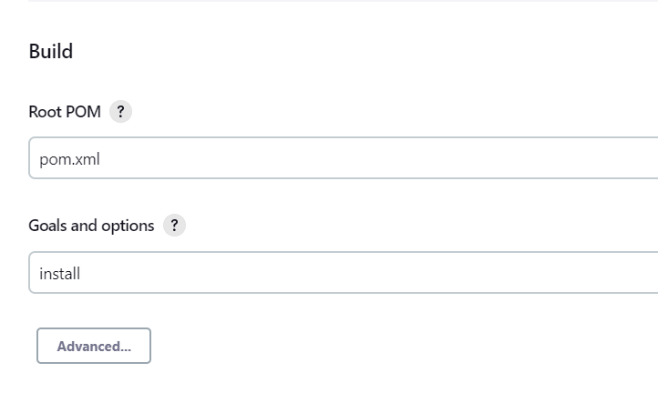

* Build it

